AI Use Declaration Form
Course: Introduction to Artificial Intelligence
Lab Title: Lab 1 Part A — Uninformed Search Algorithms
Student Name: Karen Boahemaah Kwatia
Student ID: 48062028
GitHub Repository Link: https://github.com/Karen-Kwatia/ai-course-lab0/blob/main
Date Submitted: June 05,2026

1. AI Use Summary
Question | Student Response
Did you use any AI tool for this lab? | Yes
Estimated percentage of the work influenced by AI | 9%
Did you attach evidence of AI use where applicable? | Yes

2. Details of AI Use
Complete the table below for each AI tool used. Add more rows where necessary.
Name of AI Tool Used | Purpose for Using the Tool | Prompt or Instruction Given to the Tool | Part(s) of the Work Influenced by the Tool | How I Verified, Edited, or Improved the AI Output
Claude | To check if my output is right | This is the result of everything I’ve done so far. | The solution, and exercise 4 | Compared outputs with friends
Claude | To try fixing the module not found error when my pandas model wasn’t working | Message of the error displayed in the terminal | Trying to fix the problem | Asked the FI and said it was okay to use collab

3. Attachment of AI Output Evidence
Where required, attach evidence of AI use. Tick all that apply. Add more rows where necessary.
Evidence Type | Attached? (Yes, No, N/A) | File Name
AI-generated draft | no
Prompt history | no
Screenshot of AI interaction | yes
Exported AI conversation | no
AI-generated code snippet | no
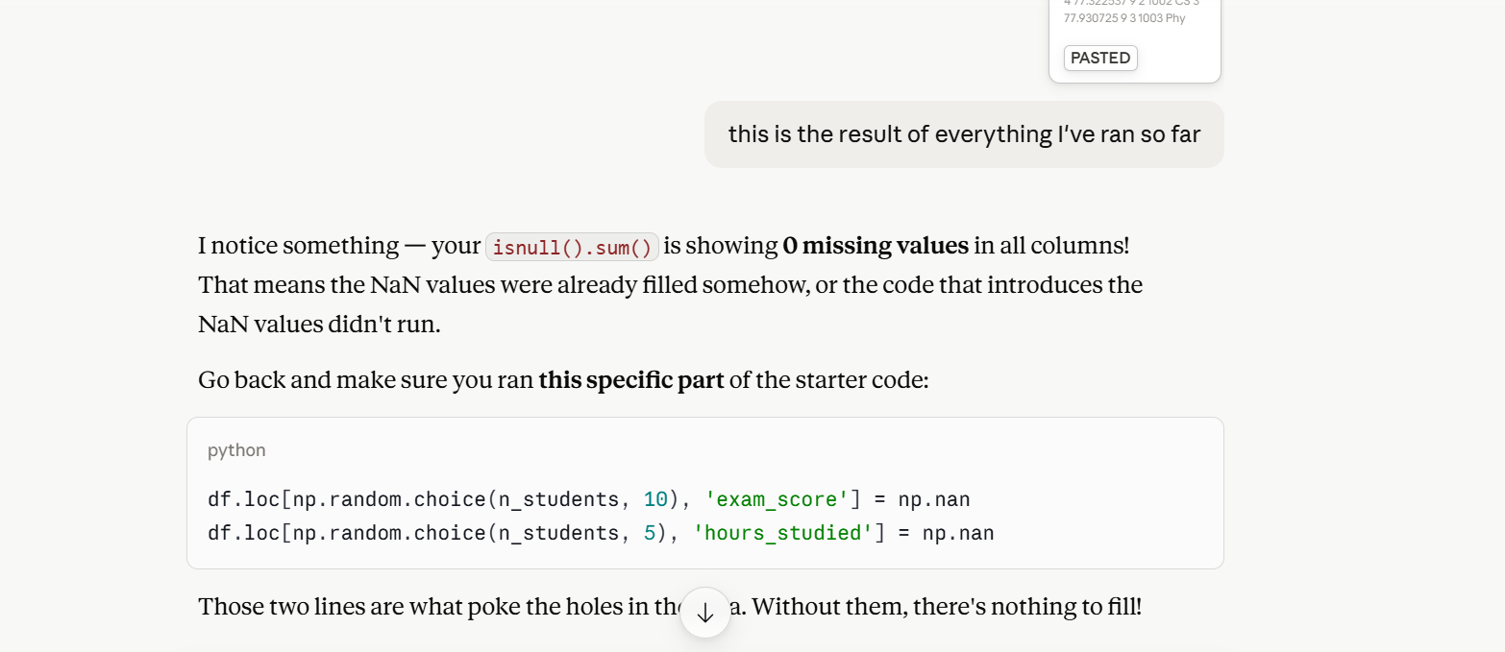
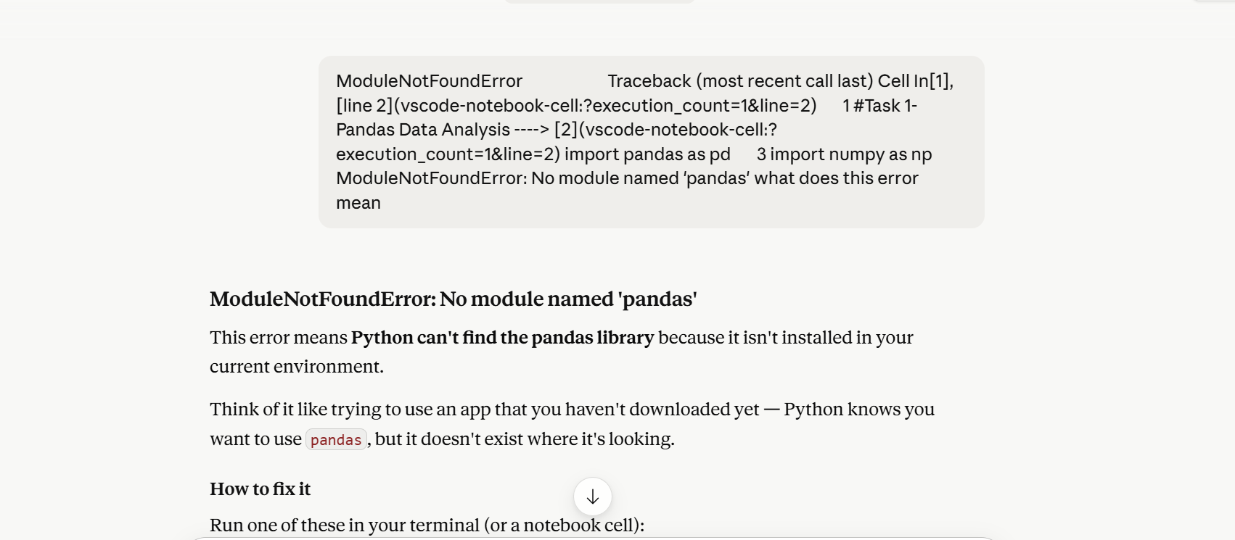

4. Student Declaration
I declare that:
Declaration Statement | Response (Yes/No)
The submitted work is my own work. | Yes
Any use of AI tools has been clearly declared in this form. | Yes
The prompts, instructions, and AI-generated outputs have been disclosed where applicable. | Yes
I reviewed, tested, edited, and improved any AI-generated content before submission. | Yes
My AI usage does not exceed 25% of the entire work. | Yes
I understand that undeclared or excessive AI use may be treated as academic misconduct. | Yes

Student Signature: ___________________K.B.K________________________
Date: June 05,2026

